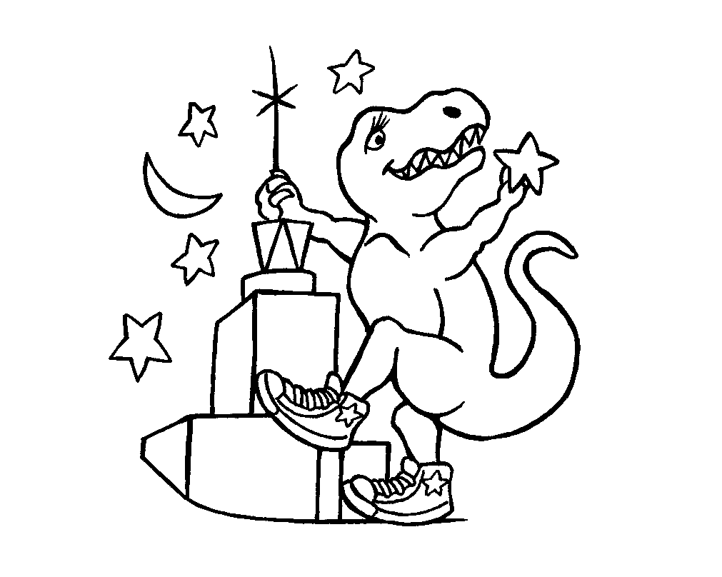

2012-2013

Museum of Science
Overnight Program
Adult Orientation Schedule

Saturday October 6 2:00 - 4:00 PM

Saturday November 3 2:00 - 4:00 PM

Saturday January 5 2:00 - 4:00 PM
Saturday February 2 2:00 - 4:00 PM

Saturday March 2 2:00 - 4:00 PM

Saturday April 6 2:00 - 4:00 PM

Saturday May 4 2:00 - 4:00 PM

We encourage everyone who has not been to an overnight to attend an Adult Orientation. Other Orientations may be scheduled in your area. Check with your Organization for times, dates and registration information.

When you arrive at the Museum of Science for an Orientation, please go to the Information Booth in the Main Lobby and you will be directed from there to the program location. If you drive, be sure to bring your parking ticket to the Information Booth, where staff will validate it for free parking.

For more information about the Orientation, please send an email to overnights@mos.org or call the overnight office at 617-589-0350.

